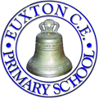Euxton Church of England Primary School
Bank Lane, Wigan Road, Euxton, Chorley, Lancashire, PR7 6JW
(01257) 263454
website: www.euxtonceprimary.co.uk e-mail: head@euxton.lancs.sch.uk
Headteacher: Mrs Mairi Ash

Dear Parents,
Robinwood Souvenirs

Robinwood offer us the opportunity to purchase a small souvenir in advance of our visit. There is no obligation to purchase a souvenir, however, should you be interested in this, the choices are below.

If you would like your child to have a souvenir, please look at the list below and complete the form underneath.

Please send payment (cash in a sealed envelope) to school by Friday 14th May.

If you have any further questions regarding this, please do not hesitate to ask.

Yours sincerely,

Helen MacDonald
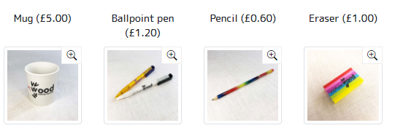

_________________________________________________________________________________

Please tick your choice below:

Name of child:_______________________

Mug £5.00 |  | Ballpoint pen £1.20
Pencil 60p |  | Eraser £1.00

In our Christian family, we all SHINE in the light of Jesus.
Wisdom Compassion Humility Friendship Peace Trust Forgiveness Hope

An outstanding and happy school underpinned by Christian values.

